Bottom of Form 1

Wheelbuilding

Why build wheels?
The wide availability of inexpensive, well-built replacement wheels has reduced the need for wheelbuilding in retail bike shops. Nevertheless, there are still times when custom built (or re-built) wheels are needed, especially in the case of higher-end bikes that have expensive hubs that are too good to throw away.
Learning to build wheels is an important milestone in the education of an apprentice mechanic. A "mechanic" who has not mastered this basic skill cannot be considered to be a fully-qualified, professional, and will always feel inferior to those who can list wheelbuilding among their skills.
Although this article was originally directed to shop mechanics, a knowledge of wheelbuilding can be invaluable to any cyclist who wishes to do his or her own maintenance and repair.
Building wheels from scratch is the best way to learn the craft of wheel truing, to get the feel for how a wheel responds to spoke adjustments. It is much easier to learn this with new, un-damaged parts than to start right in trying to repair damaged wheels.

Getting started
While an experienced wheelbuilder can build a wheel in well under an hour, as beginner should expect to spend several hours on the task. It is best not to try to do this all at one sitting, because you are likely to get frustrated at the slowness of the truing and tensioning process. Better to put the job aside, even overnight, than to get careless and ruin a good wheel-in-progress.
This article focuses on building a rear wheel, because that is the more complicated one. For front wheels, disregard that which does not apply. This will be a 36 spoke, cross 3 wheel.

Tools
You will need a small flat-bladed screwdriver, a spoke wrench (I use a DT spoke wrench, but most people aren't ready for a $50 spoke wrench. My favorite inexpensive spoke wrench is a plastic one with a metal bit, called a "Spokey"), a truing stand and a dish stick.
In addition, it is helpful to have a spoke tensiometer and an electric screwdriver with an appropriate bit. (My preferred bit is a worn-out Phillips bit, on which I have ground off two of the four fins. This leaves a pointed flat blade. The point pokes into the hole in the middle of the nipple, and helps keep the driver from sliding off.)

Materials

- Hubs
All modern hubs of decent quality are made of aluminum. Better-quality hubs are usually made by forging, and only forged hubs should be used for radial-spoked front wheels. I would generally advise avoiding overpriced "boutique" hubs which are made by CNC machining, since their flanges are usually weaker than those of forged hubs.
If you are buying new hubs, the best value for the money, in most cases, is Shimano. If you want the very best, cost no object, in many applications, this would be Phil Wood.

- Spokes
The material of choice for spokes is stainless steel. Stainless is strong and will not rust. Cheap wheels are built with chrome-plated ("UCP")or zinc-plated ("galvanized") carbon-steel spokes, which are not as strong, and are prone to rust.
The leading brands of spokes available in the U.S. market are DT and Wheelsmith.
Titanium is also used for spokes, but, in my opinion it is a waste of money. Titanium spokes should only be used with brass nipples, which makes a combination that is not significantly lighter than stainless spokes with aluminum nipples.
Carbon fibre spokes have been available, but turned out to be brittle and dangerous.

Spoke Gauges
The diameter of spokes is sometimes expressed in terms of wire gauges. There are several different national systems of gauge sizes, and this has been a great cause of confusion. A particular problem is that French gauge numbers are smaller for thinner wires, while the U.S./British gauge numbers get larger for thinner wires. The crossover point is right in the popular range of sizes used for bicycle spokes:
U.S./British 14 gauge is the same as French 13 gauge
U.S./British 13 gauge is the same as French 15 gauge
Newer I.S.O. practice is to ignore gauge numbers, and refer to spokes by their diameter in millimeters:
U.S./British 13 gauge is 2.3 mm
U.S./British 14 gauge is 2.0 mm
U.S./British 15 gauge is 1.8 mm
U.S./British 16 gauge is 1.6 mm
Spokes come in straight-gauge or swaged (butted) styles. Straight gauge spokes have the same thickness all along their length from the threads to the heads.
Swaged spokes come in 5 varieties:
- Single-butted spokes are thicker than normal at the hub end, then taper to a thinner section all the way to the threads. Single-butted spokes are not common, but are occasionally seen in heavy-duty applications where a thicker than normal spoke is intended to be used with a rim that has normal-sized holes.
- Double-buttedspokes are thicker at the ends than in the middle. The most popular diameters are 2.0/1.8/2.0mm (also known as 14/15 gauge) and 1.8/1.6/1.8 (15/16 gauge).
Double-butted spokes do more than save weight. The thick ends make them as strong in the highly-stressed areas as straight-gauge spokes of the same thickness, but the thinner middle sections make the spokes effectively more elastic. This allows them to stretch (temporarily) more than thicker spokes.
As a result, when the wheel is subjected to sharp localized stresses, the most heavily stressed spokes can elongate enough to shift some of the stress to adjoining spokes. This is particularly desirable when the limiting factor is how much stress the rim can withstand without cracking around the spoke hole.
- Triple-butted spokes, such as the DT Alpine III, are the best choice when durability and reliability is the primary aim, as with tandems and bicycles for loaded touring. They share the advantages of single-butted and double-butted spokes. The DT Alpine III, for instance, is 2.34mm (13 gauge) at the head, 1.8mm (15 gauge) in the middle, and 2.0mm (14 gauge) at the threaded end.
Single- and triple-butted spokes solve one of the great problems of wheel design: Since spokes use rolled, not cut threads, the outside diameter of the threads is larger than the base diameter of the spoke wire. Since the holes in the hub flanges must be large enough to fit the threads through, the holes, in turn are larger than the wire requires. This is undesirable, because a tight match between the spoke diameter at the elbow and the diameter of the flange hole is crucial to resisting fatigue-related breakage.
Since single- and triple-butted spokes are thicker at the head end than at the thread end, they may be used with hubs that have holes just large enough to pass the thick wire at the head end.
- Æro (elliptical) spokes are a variety of double-butted spoke in which the thin part is swaged into an elliptical cross section, which makes them a bit more ærodynamic than round-section spokes. The most widely available spoke of this type is the Wheelsmith Æro. These are 1.8mm (15 gauge) at the ends, and the middles are equivalent to 16 gauge, but in the form of a 2.0 x 1.6mm ellipse. The Wheelsmith &Aelig;ro is my favorite spoke for high-performance applications, not just because of whatever ærodynamic advantage it may offer, but because the flat center section provides an excellent visual indicator to help the wheelbuilder eliminate any residual twist in the spoke. This helps build a wheel that will stay true.
- Æro (bladed) spokes have a more pronounced æro shape, flat, rather than elliptical. Although they are the most ærodynamic of spokes, they won't normally fit through the holes in a standard hub because they are too wide. To use "blades", the hub must be slotted with a file. This can weaken the flange, and will usually void the warranty of the hub. It is also a lot of trouble.
There was a fad in the early '90s for Hoshi "blades" which had a double bend instead of a conventional head. This allowed the spokes to be inserted "head first" into the hub flange, so that they could be used with normal hubs. Unfortunately, they turned out to be prone to breakage, and I can't recommend them.
My Bicycle Glossary has a Table of Spoke Weights, for those who care about such things.

- Nipples
Nipples are commonly made of nickel-plated brass. This is a good material choice, because brass takes very smooth threads, and brass nipples don't get corroded into position too easily.
For light-weight, high-performance wheels, aluminum nipples are available. Aluminum nipples do save a small amount of weight, and they can be quite reliable if used properly. They should only be used with rims that have eyelets of some material other than aluminum, because aluminum/aluminum contact between rim and nipple can result in chemical welding, immobilizing the nipples.

- Rims
Older rims were made out of steel, but steel rims are now obsolete, and only found on the cheapest, crummiest bicycles. Aluminum rims have superceded steel, because they are lighter, stronger, rust-proof and provide better braking.
Modern rims are made of extruded aluminum, that is, the semi-molten aluminum is squeezed out of specially-shaped openings which determine the cross section of the rim. The extrusions are formed into hoops, then joined either by welding or by the insertion of a filler piece into the hollows of each end of the rim.
Many good quality rims have "eyelets" or "ferrules" to reinforce the spoke holes.

Spoke Length Calculators
Spoke length is measured from the inside of the elbow to the very end of the threads, most usually in millimeters.
When you buy spokes to match the rim, hub and pattern you will use, your dealer should be able to determine the correct length(s) for you. Most dealers these days use a computer program called "Spokemaster" which comes bundled with a wholesale database called "Bike-alog-on disk". If you need to do your own calculations, there are several spoke-length utilities available on the Web, including:
- Damon Rinard's Excell Spreadsheet, including a database of rims and hubs.
- John Buchanan's site has a calculator that requires direct numerical input of various hub and rim dimensions.
- Danny Epstein's requires numerical dimensions.
- Edmonton Bicycle Club requires numerical dimensions.
- Dan Halem's online calculator has a database of hubs and rims.
- Ben Manthey's version requires numerical dimensions.
- Roger Musson's "Wheelpro" spoke calculator has a database of hubs and rims.
- Damon Rinard's Microsoft Excel spoke calculator has a database of hubs and rims.
Sutherland's Handbook for Bicycle Mechanics has charts and tables by which you can calculate spoke lengths. Alternatively, you can measure an existing wheel of the same lacing pattern and get reasonably close.

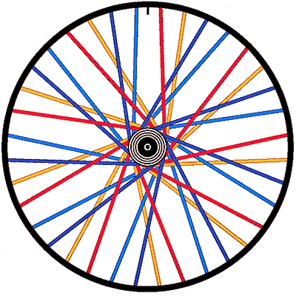
Note: all of the wheel illustrations for this article
show the wheel as viewed from the right (freewheel) side.

Preparation
Spoke threads and spoke holes in the rim should generally be lubricated with light grease or oil to allow the nipples to turn freely enough to get the spokes really tight. This is less important than it used to be due to the higher quality of modern spokes, nipples and rims, but it is still a good practice. In the case of derailer rear wheels, only the right side spokes and spoke holes need to be lubricated. The left side spokes will be loose enough that it will not be hard to turn the nipples even dry, and if you grease them they may loosen up of their own accord on the road.

Lacing
Lacing is most easily done sitting down, holding the rim on edge in your lap. People who build wheels all day long start by putting all of the spokes into the hub, then connecting them to the rim one after another. This approach is slightly faster on a production basis, but the occasional builder runs a higher risk of making lacing errors this way.
Non-production wheelbuilders usually put the spokes in one "group" at a time. A conventional wheel has 4 "groups" of spokes: Half of the spokes go to the right flange, and half go to the left. On each flange, half are "trailing" spokes and half are "leading" spokes.

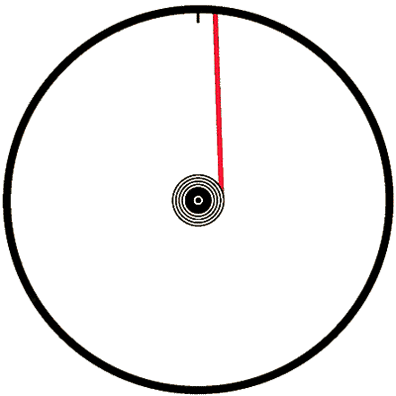
The "key" spoke
The first spoke to be installed is the "key spoke" .
This spoke must be in the right place or the valve hole will be in the wrong place, and the drilling of the rim may not match the angles of the spokes. The key spoke will be a trailing spoke, freewheel side. It is easiest to start with the trailing spokes, because they are the ones that run along the inside flanges of the hub. If you start with the leading spokes, it will be more awkward to install the trailing spokes because the leading spokes will be in the way.
Since the key spoke is a trailing spoke, it should run along the inside of the flange. The head of the spoke will be on the outside of the flange. (see sidebar "Which side of the flange?")
It is customary to orient the rim so that the label is readable from the bicycle's right side. If the hub has a label running along the barrel, it should be located so that it can be read through the valve hole. These things will not affect the performance of the wheel, but good wheelbuilders pay attention to these things as a matter of pride and esthetics.
Rims are drilled either "right handed" or "left handed". This has to do with the relationship between the valve hole and the spoke holes. The spoke holes do not run down the middle of the rim, but are offset alternately from side to side. The holes on the left side of the rim are for spokes that run to the left flange of the hub. with some rims the spoke hole just forward of the valve hole is offset to the left, with others it is offset to the right (as illustrated). Which type is "right handed" and which "left handed"? I have never met anyone who was willing to even make a guess!
The key spoke will be next to or one hole away from the valve hole in the rim.
As viewed from the right (freewheel) side of the hub, the key spoke will run counterclockwise, and it will go to either the hole just to the right of the valve hole (as illustrated) or the second hole to the right, depending on how the rim is drilled. The aim is to make the four spokes closest to the valve hole all angle away from the valve, giving easier access to the valve for inflation.
Screw a nipple a couple of turns onto the key spoke to hold it in place. Next, put another spoke through the hub two holes away from the key spoke, so that there is one empty hole between them on the hub flange. This spoke goes through the rim 4 holes away from the key spoke, with 3 empty holes in between, not counting the valve hole.
Continue around the wheel until all 9 of the first group of spokes are in place. Double check that the spacing is even both on the hub (every other hole should be empty) and the rim (you should have a spoke, 3 empty holes, a spoke, etc. all the way around. Make sure that the spokes are going through the holes on the same side of the rim as the flange of the hub. It should look like this:
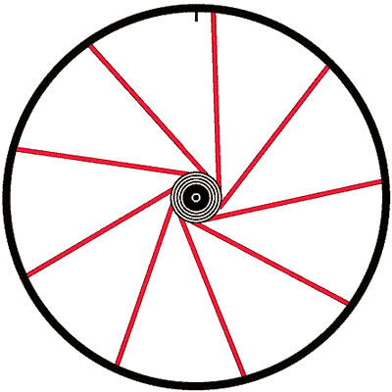

The second group
Now turn the wheel over and examine the hub. The holes on the left flange do not line up with the holes on the right flange, but halfway between them. If you have trouble seeing this, slide a spoke in from the left flange parallel to the axle, and you will see how it winds up bumping against the right flange between two spoke holes. Turn the wheel so that the valve hole is at the top of the wheel. Since you are now looking at the wheel from the non-freewheel side, the key spoke will be to the left of the valve hole.
If the key spoke is next to the valve hole, insert a spoke into the left flange so that it lines up just to the left of where the key spoke comes out of the hub, and run it to the hole in the rim that is just to the left of the key spoke.

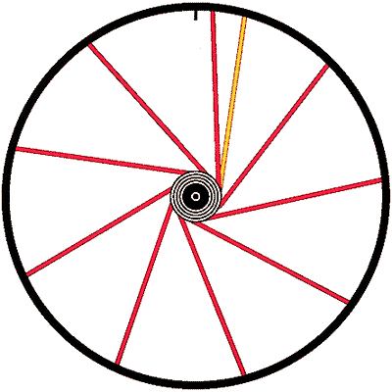
The illustration shows it viewed from the right side:
If the key spoke is separated from the valve hole by an empty spoke hole, insert a spoke into the left flange so that it lines up to the right of where the key spoke comes out of the hub, and run this tenth spoke to the hole between the key spoke and the valve hole
If you have done this correctly, the spoke you have just installed will not cross the key spoke. If it is to the left of it at the hub, it will be to the left of it at the rim. Like the first group of spokes, it will be a trailing spoke, it will run along the inside of the flange, and the head will face out from the outside of the flange. Install the other 8 spokes in this group following the same pattern.
At the end of this stage, the wheel will have all 18 of the trailing spokes in place. In the rim, there will be two spokes, two empty holes, two spokes, two empty holes...etc. as shown below:
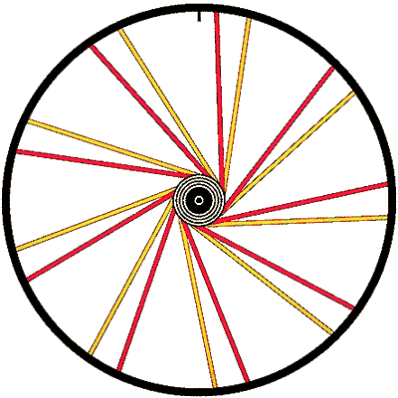
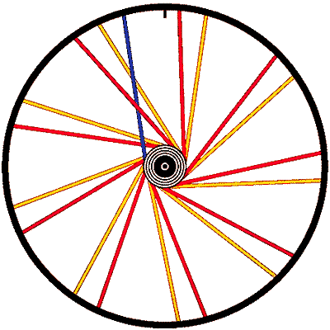
The leading spokes

Turn the wheel back around so that the freewheel side is toward you. Insert a spoke into any hole, but this time from the inside of the flange. Twist the hub clockwise as far as it will conveniently go. Since we are building a cross 3 wheel, this new spoke will cross 3 trailing spokes that go to the same flange of the hub.
The first two crosses, this spoke will pass outside of the trailing spokes, but for the outermost cross it should be "laced" so that it goes on the inside of the last trailing spoke. You will have to bend this leading spoke to get it around the last trailing spoke on the correct side.
After this leading spoke has crossed 3 trailing spokes, there will be two possible rim holes to connect it to. Use the rim hole that is on the same side as the flange you are working from. It should not be right next to one of the trailing spokes that runs from the same flange of the hub.
Install the other 17 leading spokes following the same pattern. If you can't get some of the spokes to reach their nipples, make sure that the nipples on the trailing spokes are seated into their holes. When you are done, double check around the rim to make sure that every other spoke goes to the opposite flange of the hub.

Initial spoke adjustment
Once the wheel is laced, adjust all of the nipples so that each is screwed equally far onto its spoke. You should be able to do this with a screwdriver, preferably electric. A good starting point is to set them all so that the threads just disappear into the nipples. If the spokes are a bit on the short side, you may have to leave a few threads showing. The important thing at this stage is to get all 36 spokes to be as close as possible to the same setting, all pretty loose. Some may be a bit tighter or looser, but they should all be adjusted the same to provide a baseline. If you find some are much tighter than others, double check the spoking pattern. With some rims, the rim seam is thicker than other parts of the rim, so you may need to loosen up the two spokes closest to the seam (usually opposite from the valve hole) a couple of turns.
At this stage, the spokes will not be running straight, but will be noticeably curved where they leave the hub. The leading spokes, in particular, will be swooping outward as they leave the hub then gradually curving back toward the rim. Before you start applying tension to the spokes you should bend them by hand so that they fit snugly against the sides of the hub flanges. This can be done easily by pressing on each spoke in turn with your thumb about an inch out from the hub. If you don't do this, the spokes will still be slightly curved when the wheel is finished. These curves will gradually straighten themselves out over the first few hundred miles on the road, and the wheel will lose tension and go out of true.

Tensioning and truing
Now you are ready to put the wheel into the truing stand. If you are lucky it will already be fairly true, but don't be surprised if it is way off. If the spokes are still very loose, so that you can wiggle the rim back and forth easily, tighten each spoke one full turn. Start at the valve hole and work your way around until you get back to it, so that you won't lose count. Make sure you are turning the nipples the right way.
When you work with a screwdriver, it is easy to figure out which way tightens them, clockwise. It gets confusing when you start using the spoke wrench, because now you are working from the back side of the clock!
Continue bringing up the tension one full turn at a time until the wheel begins to firm up.
Once there begins to be a little bit of tension on the wheel, you should start bringing it into shape. There are 4 different things that you need to bring under control to complete the job: lateral truing, vertical truing, dishing, and tensioning. As you proceed, keep checking all 4 of these factors, and keep working on whichever is worse at the moment.
Try to make your truing adjustments independent of each other. For lateral truing, spin the wheel in the stand and find the place on the rim that is farthest away from where most of the rim is. If the rim is off to the left, tighten spokes that go to the right flange and loosen those that go to the left flange. If you do the same amount of tightening and loosening, you can move the rim to the side without affecting the roundness of the wheel. For example, if the rim is off to the left, and the center of the bend is between two spokes, tighten the spoke that goes to the right flange 1/4 turn, and loosen the spoke that goes left 1/4 turn; If the center of the left bend is next to a spoke that goes to the right flange, tighten that spoke 1/4 turn, and loosen each of the two left spokes next to it 1/8 turn; If the center of the left bend is next to a spoke that goes to the left flange, loosen that spoke 1/4 turn, and tighten each of the two right spokes next to it 1/8 turn. After adjusting the worst bend to the left, find the worst bend to the right, and adjust it. Keep alternating sides. Don't try to make each bent area perfect, just make it better, then go on to the next. The wheel will gradually get truer and truer as you go.
For vertical truing, find the highest high spot on the rim. If the center of this high spot is between two spokes, tighten each of them 1/2 turn. If the high spot is centered over one spoke, tighten that spoke one full turn, and each of the two spokes next to it that go to the other flange, 1/2 turn. It takes a larger adjustment to affect the vertical truing than the horizontal truing. Vertical truing should usually be done by tightening spokes, gradually building up the tension in the wheel as you go along.
As soon as the lateral truing gets reasonably good (within a couple of millimeters) start checking the dishing. Put the adjustable feeler of the dish stick over the axle on one side of the wheel and adjust it so that both ends of the dish stick touch the rim while the middle feeler rests against the outer locknut on the axle. Then move the stick to the other side of the wheel without re-adjusting the feeler. If the dish stick rocks back and forth while in contact with the outer locknut, the spokes on that side of the wheel have to be tightened to pull the rim over. If the ends of the dish stick sit on the rim but the feeler won't reach the locknut, the spokes on the other side of the wheel need to be tightened. If the dishing is off by more than 2 or 3 millimeters, you should start at the valve hole and work your way around the rim tightening up all 18 spokes on the appropriate side the same amount, perhaps 1/2 turn.
When the dish is starting to get within 1 or 2 millimeters of being correct, go back to working on the lateral truing, except now you will not be alternating sides. If the rim needs to move to the right to improve the dish, find the worst bend to the left, adjust it, then find the new worst bend to the left, and so on.
All the time you are doing this you need to keep checking the vertical truing, and whenever the vertical error is greater than the lateral error, work on the vertical.
You also need to keep monitoring the tension on the freewheel side spokes. There are three ways to check tension. One is by how hard it is to turn the spoke wrench. If it starts to get hard enough that you have to start worrying about rounding off the nipple with the spoke wrench, you are approaching the maximum. Fifteen years ago, this would be the limiting factor, and you would just try to get the wheel as tight as you could without stripping nipples. Modern, high quality, spokes and nipples have more precisely machined threads, however, and now there is actually a possibility of getting them too tight, causing rim failure.
The second way of judging spoke tension is by plucking the spokes where they cross and judging the musical pitch they make. If your shop doesn't have a piano, and you don't have perfect pitch, you can compare it with a known good wheel that uses the same gauge of spokes. This will get you into the ballpark. Before I started using a spoke tensiometer, I used to keep a cassette in my toolbox on which I had recorded my piano playing an F#, a good average reference tone for stainless spokes of usual length. (For more details on this method, see John Allen's article: Check Spoke Tension by Ear.)
The third, and best way is with a spoke tensiometer. Every well equipped shop should have one. Average freewheel-side tension should be up to shop standards for the type of spokes and rim being used. More important is that it be even. Don't worry about the left side tension on rear wheels. If the freewheel side is correctly tensioned, and the wheel is correctly dished, the left side will be quite a bit looser. You should still check the left side for uniformity of tension.

Spoke Torsion
As the wheel begins to come into tension, you start to have to deal with spoke torsion. When you turn your spoke wrench, the first thing that happens is that the spoke will twist a bit from the friction of the threads. Once the nipple has turned far enough, the twist in the spoke will give enough resistance that the threads will start to move, but the spoke will remain twisted. What a good wheelbuilder can do that a robot machine can't do is feel this twist. If you "finish" you wheel up, and it is perfectly true in your stand, but the spokes are twisted, the wheel will not stay true on the road. The twist in the spokes will eventually work itself out, and the wheel will go out of true.
This problem can be prevented by sensitive use of your spoke wrench. What you need to do is overshoot and backlash. In other words, suppose you want to tighten a particular spoke 1/4 turn. You don't just turn the wrench 1/4 turn, you turn it a little farther, then back it up that same little bit. The nipple winds up being 1/4 turn tighter, but the backing up releases the twist in the spoke.
This is much easier to do on straight-gauge spokes, because they are stiffer torsionally, and it is easier to feel the twist than it is with butted spokes. This is one of the reasons I like "aerodynamic" spokes so much; not so much for the aerodynamics, as for the fact that you can tell visually if they are twisted.

Seating and Stress Relieving the Spokes
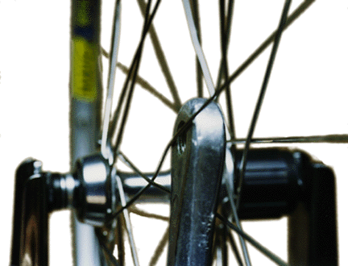
Before a wheel is ready for the road it must be stress relieved, because the bend in the spoke has to accommodate itself to the shape of the hub flange and vice versa, and a similar process may go on where the nipple sits in the rim. Some wheelbuilders do this by flexing the whole wheel, others by grabbing the spokes in groups of 4 and squeezing them together. My preferred technique is to use a lever to bend the spokes around each other where they cross. My favorite lever for this is an old left crank:
This particular technique has the added advantage of bending the spokes neatly around each other at the crossing, so they run straight from the crossing in both directions. As you go around the wheel this way you will probably hear creaks and pinging sounds as the parts come into more intimate terms with each other.
After you do this, you will probably have to do some touch-up truing, then repeat the stressing process until it stops making noise and the wheel stops going out of true.
Jobst Brandt, author of the excellent book The Bicycle Wheel points out a less obvious benefit of this stressing of the spokes:
"...After cold forming, steel always springs back a certain amount (spokes are entirely cold formed from wire). Spring-back occurs because part of the material exceeded its elastic limit and part did not. The disparate parts fight each other in tension and compression, so that when the spoke is tensioned, it adds to the tensile stress that can be, and often is, at yield.
"...When spokes are bent into place, they yield locally and addition of tension guarantees that these places remain at yield. Because metal, at or near the yield stress has a short fatigue life, these stresses must be relieved to make spokes durable.
"...These peak stresses can be relieved by momentarily increasing spoke tension (and stress), so that the high stress points of the spoke yield and plastically deform with a permanent set. When the stress relief force is relaxed these areas cannot spring back having, in effect, lost their memory, and drop to the average stress of the spoke."
If you have done this, you will wind up with a wheel that is true and round, and will stay that way better than most machine made wheels. In addition, you will have learned a lot about truing wheels, and you will feel more like a real professional mechanic.

Definitions:
This article uses 3 non-standard terms, because standard terms have not been agreed upon in the industry:
- "Key" spoke. This is the first spoke to be installed in building the wheel. It's position determines the position of all the other spokes.
- "Trailing" spokes. In the case of a rear wheel, the trailing spokes are those which become tighter when the rider applies pressure to the pedals. They are called "trailing" because they point backward from the direction the hub is turned in. In the illustrations for this article, the trailing spokes are shown in red and yellow.
- "Leading" spokes. These are the spokes that exit the hub in the direction of rotation. They are illustrated in two shades of blue.
The "trailing" spokes pull harder under drive torque to make the rim turn, and the "leading" spokes contribute by pulling less hard under driving torque. Each group of spokes contributes equally in its own way to turning the rim to keep up with the hub.
Some writers have referred to the trailing spokes as "driving" or "pulling" spokes, and have referred to the leading spokes as "tension" or "static" spokes. These terms may be confusing, because all of the spokes contribute to driving, they are all under tension and they all pull. Depending on how you look at it, either all of them or none of them are "static". (Thanks to John Forester for suggesting "leading" and "trailing".)

Which Side of the Flange?
Derailer rear wheels should be laced with the trailing spokes running up along the inside of the flange. There are three reasons for this:
- The spokes are bent around each other at the outermost crossing. Under drive torque, especially in low gear, the trailing spokes straighten out and the leading spokes bend even more. If the wheel is laced with the trailing spokes on the outside of the flange, the crossing gets pulled outward toward the derailer cage, and in some cases will actually hit against the derailer only under load.
- If the chain should overshoot the inner sprocket due to the derailer being mis-adjusted or bent, it is likely to get more seriously jammed between the spokes and the freewheel if the spokes slant so as to wedge the chain inward under load.*
- If the chain should overshoot the inner sprocket, it may damage and weaken the spokes it rubs against. Since the trailing spokes are more highly stressed than the leading spokes, it is better to protect them from this type of damage by keeping them inboard.
It really doesn't matter which way you go on the left side, but if you have all the trailing spokes face inward it makes lacing the wheel a bit easier.
* In the case of fixed-gear or coaster-brake wheels, it is better to lace the opposite way, because a derailed chain is more likely to get jammed by backpedaling in these cases.

Spoke Patterns:

Semi-tangent
Conventional "semi-tangent" spoke patterns are indicated as "cross 3", "cross 4", etc. For example, cross 3 means that each spoke crosses 3 other spokes that run from the same flange of the hub. Most wheels are built cross 3. Higher cross numbers cause the spokes to leave the hub flange more nearly at a tangent. This makes them better able to withstand the twisting forces of hard pedaling in low gears, and also braking forces in the case of hub brakes. Lower cross numbers make the spokes more nearly perpendicular to the hub flange, and to the rim.
In the case of the "radial" (cross 0) pattern the spokes go straight out from the hub without crossing at all. Lower cross patterns use shorter spokes, so they are slightly lighter, and they can also be slightly stronger side-to-side.
The more spokes a wheel has, the higher the cross number for a similar spoke angle. 48 spoke wheels are usually built cross 5, 40 spokes, cross 4; 36 spokes, cross 3 or 4; 32 spokes, cross 3; 28 or 24 spokes, cross 2...
In the case of unusually large hubs, particularly large hubs in small rims, fewer crosses are often indicated, to avoid bending the spokes where they exit the nipples. For example, the Rohloff Speedhub has 32 spoke holes, but is usually laced cross 2.

Radial Spoking
Radial spoked (cross 0) wheels have the spokes going straight out from the hub. This pattern is only suitable for front wheels that don't use hub brakes. They are very cool-looking, and are often a good choice for the ultimate in performance, because they are slightly lighter and, in theory, may have a very slight aerodynamic edge.
There are two things to watch out for with radial wheels. Because the nipples point straight inward from the rim, they can turn more easily in most rims than when they are bent to a slight angle by a semi-tangent spoke pattern. This ease of turning increases the risk of them unscrewing themselves on the road. To prevent this, nipples on radial wheels should not be lubricated, and it is a good idea to use a spoke adhesive such as Wheelsmith Spoke Prep or one of the milder flavors of Loctite ® on them.
The other potential problem with radial wheels is that since the spokes are trailing straight outward on the hub flange, they can possibly rip the outer edge of the flange right off along the line of the spoke holes. This is most likely to happen with small flange 36 hole hubs, because there is less metal between the spoke holes. If a used hub is re-laced radially, the notches left by the old spokes can act as stress risers, further weakening the flange.
Bicycle folklore has it that radial-spoked wheels give a "harsh" ride, because the shorter spokes are less "stretchy" than the longer spokes used in semi-tangent wheels. This is hooey!

Half-radial Spoking
More and more rear wheels now are built "half-radial" with semi-tangent spoking on the right side and radial spoking on the left. Radial front wheels offer mainly esthetic benefits, but half radial rear wheels are substantially more durable than conventional ones. The high amount of dishing called for to make room for more and more sprockets has caused an increase in spoke breakage on the left side of rear wheels. This is caused by metal fatigue.
A spoked wheel relies on having all of the spokes in constant tension. A highly dished rear wheel starts with very light tension on the left side spokes. The torque of hard pedaling can cause the left side "leading" spokes to occasionally go completely slack momentarily. Repeated cycles of tension and slackness cause these spokes to fatigue at the bends, and ultimately break.
With half-radial spoking, the amount of dish is slightly less to begin with if you run the radial spokes up along the inside of its flange. In addition, since there are no "leading" spokes, no amount of torque on the hub can reduce the tension on any of the spokes. In fact, if you have a customer who has been breaking left side spokes, "half rebuilding" the wheel into a half radial will solve the problem once and for all.
I used to think that this was exotic, cutting edge technology, until I happened to look at a couple of Model A Fords in a local parade. Their wheels were highly dished inward, and were laced in the same half-radial pattern, for the same reason.

Exotic Patterns
These are not the only possibilities, but they are the practical ones. It you want information on whimsical patterns such as the crow's foot, et. al. check out http://www.terminalvelocity.demon.co.uk/WheelBuild/
Even more whimsical are my own POWerwheels spoking pattern, and the SYMMETRISPOKE nipples that go with it.

Further Reading
For a more thorough analysis of some of the theoretical aspects of spoked wheels, the standard reference book is The Bicycle Wheel, by Jobst Brandt (1981 Avocet, Palo Alto, California ISBN 0-9607236-6-8.) This is available at better bicycle shops everywhere.
The use of musical pitch to determine spoke tension is explained in Glenn's New Complete Bicycle Manual revised and updated by John Allen (1987 Crown Publishers, Inc. New York ISBN 0-517-54313-3) p.380. This article is also available on the Web at http://www.bikexprt.com/bicycle/tension.htm
Rafæl Raban has an interesting Web page on spoke metallurgy, with photomicrographs illustrating grain structure.
In addition to Dan Halem's Spoke Length Calculator and the Wheel Wizard Web Site, A useful set of charts for determining spoke lengths may be found in Sutherland's Handbook for Bicycle Mechanics by Howard Sutherland, Sutherland Publications, Box 9061, Berkeley, California 94709. ISBN 0-914578-06-5
This is not the only wheelbuilding site on the Web. I'd also direct your attention to:
- Raleigh Wheel-Building Instructions (1960's vintage)
- Pege Ruckleshaus's Wheelbuilding Guide
- Robin Tivy's Wheelbuilding Article
- Rayonnage (French weelbuilding article) on the large French MTB site VTT.ORG

Tools and Materials
If you have trouble finding tools and materials, in your local area, you can order from Harris Cyclery:
- Tools
- Materials
For the ne plus ultra of dishing gauges, see the Hoadley-True site.

About the Illustrations
These illustrations have been around! I created them in the early '80's on a modified Digital PDP-11, using Management Graphics proprietary software, outputting Kodachrome slides. Years later, the slides were scanned onto a Photo CD, then manipulated on my Macintosh, using Adobe Photoshop.
Thanks to John Allen, Daniel Boals, Jobst Brandt, and John Forester for their kind assistance.

Feedback? Questions?
Articles by Sheldon Brown and others
Harris  Home | Beginners | Brakes | Commuting  Lights | Cycle-  Computers | Do-It-  Yourself | Essays
Family  Cycling | Fixed Gear  Singlespeed | Frames &  Fitting | Gears &  Drivetrain | Bicycle  Humor | Bicycle  Glossary | Bicycle  Links
Old  Bikes | Repair  Tips | Tandems | Touring &  France | What's  New | Wheels | Sheldon  Brown

Accessories | Bicycles | Parts | Specials | Tools
Copyright 1995, 2003, Sheldon C. Brown

For other articles by Sheldon Brown, go back to the Harris Cyclery Home Page
If you would like to make a link or bookmark to this page, the URL is:
http://sheldonbrown.com/wheelbuild

