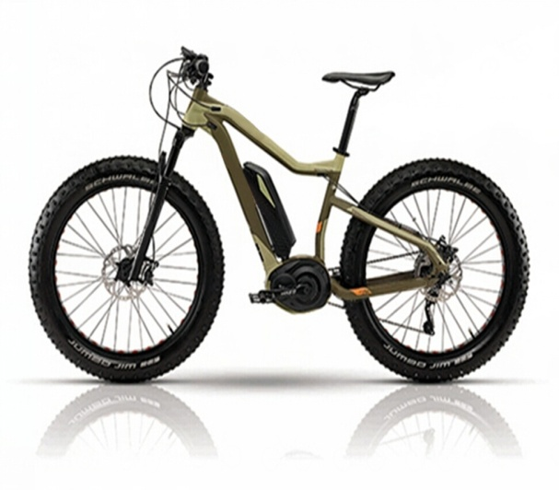

|  |  |
| --- | --- |
| 1. Frame material : aluminum 2.Control model:  a) intelligent assistance power(1：1)  b) electric motor 3.Rated power of motor: 500W-1000W 4. Load:  110kg 5. Battery: 36V/12Ah lithium battery 6.Range per charge: 40-45km  7.Charge time: 4 - 8 hrs 8.Power consumption: 1.1kWh/100km 9. Charge voltage: AC90V-260V 10. Tire size : 24'' 26” 28”” | 11. Shimano 6 speeds gear Net Weight: 23kg  Size of Packing:  138x 21 x 70 cm  Conveyance: Qty/20' FCL: 145pcs Qty/40' FCL: 295pcs Qty/40' HQ: 345pcs |